FOR IMMEDIATE RELEASE

Explosive Sequel from Author S.S.Segran Hits the
Amazon Kindle Bestseller List Ahead of The Hunger Games and Maze Runner

AEGIS INCURSION by S.S.Segran

Buffalo, Wyoming – June 22, 2015 – AEGIS INCURSION the eagerly awaited sequel to the award-winning YA action-adventure thriller, AEGIS RISING, was officially launched on Friday, June 19, 2015 with extensive blog tours and exciting giveaways. Following the trailblazing path of her debut novel, S.S.Segran’s second novel has made it to the No. 1 spot on Amazon Kindle’s Bestseller List ahead of iconic titles such as The Hunger Games, Maze Runner and Allegiant.

Released eighteen months on the heels of the first novel, AEGIS INCURSION expands the arc of the apocalyptic action-adventure story while continuing to follow the journey of its five teenage heroes. Since its release the sequel has received over one-hundred-and-fifty positive reviews and glowing accolades from readers and prominent reviewers.

A review by The US Review of Books, which gave the book a ‘recommended’ status says, “A good sequel stands alone as a strong work without the accomplishments of its predecessors, but a great sequel inspires readers to go back and relive a book they've already read, and that is precisely what this book accomplishes.” A more colorful review by the OnlineBookClub states, “If Daniel Silva and Rick Riordan had a love child, it would be the young S.S.Segran. With the intensity of an adult spy thriller and relatable characters that teenagers enjoy, Aegis Incursion takes YA Action, Adventure and Fantasy to a new level.”

While the main setting for the first book was a fictional hidden valley called Dema-Ki in northern Canada, the second book takes the reader on a gripping adventure across multiple U.S. states. The key theme of the plot in AEGIS INCURSION is a major global crop failure initiated by a shadowy organization with an apocalyptic agenda. The author travelled to several places across the US on a road trip during the summer of 2014 to research for the book. It included a trek through an arid landscape in scorching 118-degree heat in search of St. Thomas, a ghost town that was once submerged in Lake Mead, Nevada. Founded by Mormon settlers in 1865, the town plays a significant role in AEGIS INCURSION. Incidentally the north arm of Lake Mead holds another historical treasure that the author explores in her book. In 1948, a B-29 Superfortress on a top-secret research mission crashed into the mirror-like waters of the lake and sank, remaining lost for over fifty years. The crash and the mystery surrounding the aircraft are featured in the book as well. "I am thrilled and grateful for the amazing response that the Aegis League series has received from readers around the world," says S.S.Segran. "I see it as a testimony that wholesome and engaging Young Adult reads that are family-friendly remain a healthy genre in today's literary landscape.”

About the Author. S.S.Segran spent a good chunk of her childhood exploring the enchanted forest of a million tales in the mystical land of books. In her early teens, she began crafting intriguing new worlds and conjuring up characters who came alive with the flick of her wand... err... pen. Charmed by the magical response to her debut novel from readers around the world, she has embarked on a quest to take her cherished fans on a thrilling journey deeper into the Aegis universe. Even as she delves into her creative endeavors, the author intends to continue her work of supporting youths in developing countries realize their potential through her non-profit organization AegisLeague.org.
When not devouring a book or writing one, S.S.Segran can be found standing behind the cauldron of life, stirring a potion made up of chores, parkour, drawing, horseback riding and--having enjoyed jumping off a perfectly fine airplane at fifteen thousand feet - perhaps skydiving.
For more information please visit www.sssegran.com (downloadable media kit available)
For media bookings contact INKmagination LLC at 307-222-0440 or media@inkmaginationbooks.com

CONTACT LIST
Media Queries
INKmagination LLC
(307) 222-0440
media@inkmaginationbooks.com

Amazon Author Page
http://www.amazon.com/S.-S.-Segran/e/B00H2YL1P0/ref=ntt_dp_epwbk_0

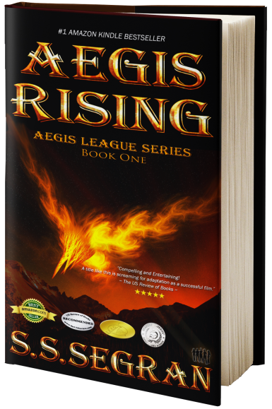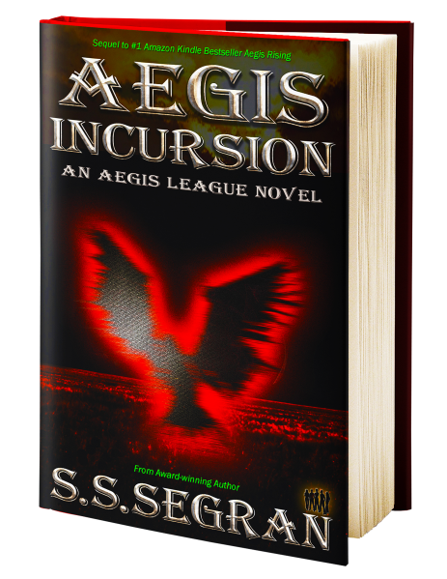
IMAGE 1: Author S.S.Segran IMAGE 2: Aegis Rising IMAGE 3: Aegis Incursion

####################################################################################

